Edge of Sorrow

Developed By:

Goldbarth Prod.

Revision: 0.0.3

# Document History

|  |  |  |  |
| --- | --- | --- | --- |
| **Version** | **Date** | **Summary** | **Author(s)** |
| 0.0.1 | 25.11.2023 | Initial Draft | Felix Wahl |
| 0.0.2 | 13.12.2023 | Post-Feedback adjustments | Felix Wahl |
| 0.0.3 | 09.01.2024 | Pre-Alpha patch | Felix Wahl |

Table of Contents

Document History 1

Game Summary 3

Target Platform(s) 3

Business Model 3

Game Overview 3

Theme / Setting / Genre 3

Core Gameplay Mechanics 3

Unique Selling Point 4

Story and Gameplay 4

Story 4

Core Gameplay 4

Meta-Games 4

Level Design 5

Asset List 6

Reflection 6

# Game Summary

A quick summary of the game / high level big picture.

* Fast-Pace First-Person Arena Shooter
* /w Item-Shop (Weapons & Upgrades)
* Permadeath

## Target Platform(s)

* PC (itch.io)

## Business Model

This will be a free to play game only for the portfolio.

# Game Overview

## Theme / Setting / Genre

The Game plays in a (dark) Sci-Fi Setting with Horror-Element



Source: Devil Daggers (Gameplay)

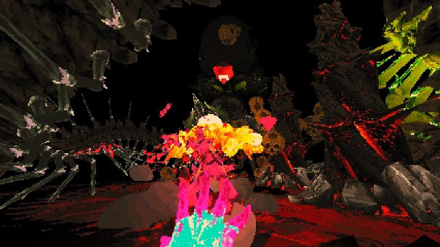 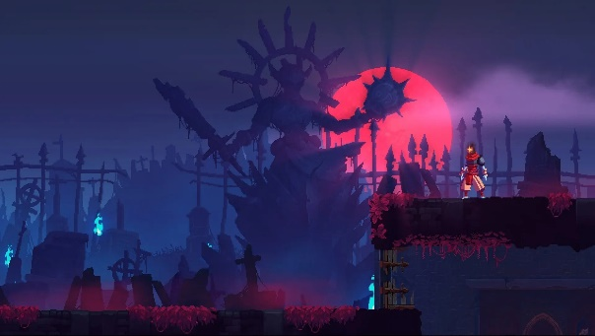

Source: Devi Daggers (FPS Dark-Horror) Source: Dead Cells (Colors and Pixelation)

## Core Gameplay Mechanics

EOS mechanics are similar to Devil Daggers and Hyper Demon.

There is an Item-Shop between the Levels to buy Weapons and other Items.

The player has to assert himself in an arena against monsters, demons and other creatures.

Some enemies drop orbs to upgrade your weapon stats, such as fire-rate.

Between some rounds, it is possible to buy items and improvements with currency collected in battle in order to improve yourself.

The rounds become more difficult as the environment changes with obstacles/traps. The enemies become more aggressive and the number increases.

There are other ideas for making the game more difficult, such as changing the lighting conditions or adding jump scares.

There should still be a fun component from time to time, such as funny weapons and ammunition or hit feedbacks with squeaky duck sounds.

* The interaction from the fast-pace shooter element and the rest period in the Item-Shop makes it more balanced (if time permits, more rest period options will be implemented between levels).
* The "fun elements" take out some of the tension.

## Unique Selling Point

This type of game with store elements is completely new and represents a different approach to creating a new, more individual experience than is usual in this genre.

# Story and Gameplay

## Story

There is no explicit Story yet. Maybe a minimal storyline will be added.

## Core Gameplay



## Meta-Games

In the Item-Shop it is possible to buy weapons and shields. The items have a level system. E.g. you can buy a pistol from level 1-3. Each level has a different feature, such as explosive rounds or higher shield capacity.

# Level Design

Quick short Levels. It starts with low number of enemies with low attribute values.

It will slowly decrease from level to level.

Every 3 levels there will be the option to buy Items in the shop.

The level design and art will vary a bit to keep the eye interested.

An example of a beginner level:

A simple circular platform where a low number of slow enemies will get closer to the player if the player is in sight.

An example of a complex level:

A platform with obstacles and/or missing ground where fast enemies track the player immediately from the level start. Also respawning enemies where the “spawn source” has to be destroyed to stop it.

Placeholder:

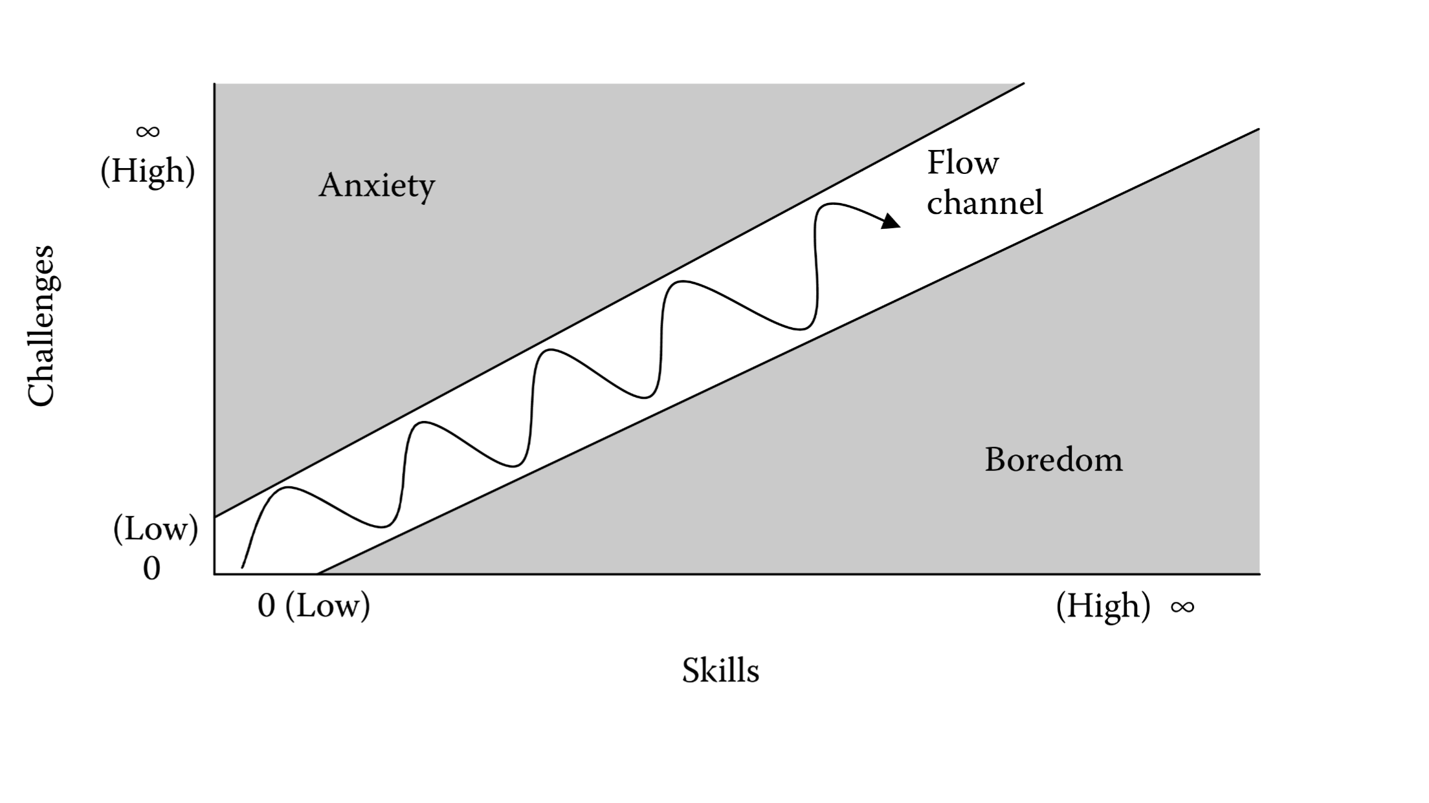

# Asset List

* Art
  + 3D
    - Post processing with Cel- and Pixelation-Shader
* Environment Art
  + Elements and Objects
    - Hell, GeorgeShachnev
* UI - Icons, Buttons, Pop Ups
  + TBA
* Game Objects
  + Enemies:
    - Hell: Doll Head, GeorgeShachnev
    - City of Brass: Enemies, UppercutGames
  + Weapons:
    - SciFi EyeRifle Elite Ver, SnowyTrain Market
    - Fantasy Weapons Pack, SnowyTrain Market
  + Tools
    - TBA
* Particle FX
  + TBA
* Sound Effects
  + TBA
* Music
  + TBA
* All Writing
  + Quest Scripts
    - TBA
  + Story ‘Screenplay’
    - TBA
* Level Design Documents
  + TBA

# Reflection

* Added: Weapon Level-System to the Item-Shop with different features per level to get a more dynamic gameplay and to keep the player interested.